Eby J Kavungal
S5 CSE BETA
U2203085
R.no: 14

Mongo DB Outputs
33)
1) Insert 10 documents into the collection.
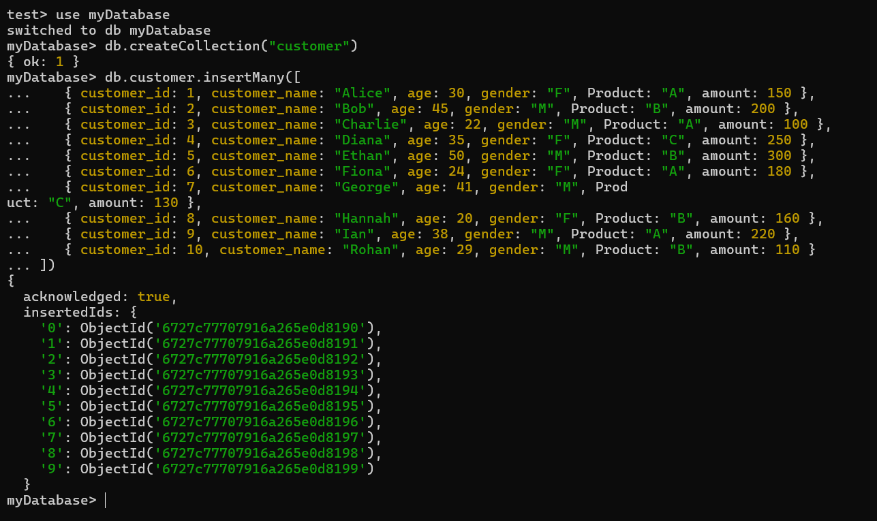
2) Read all documents from the collection.
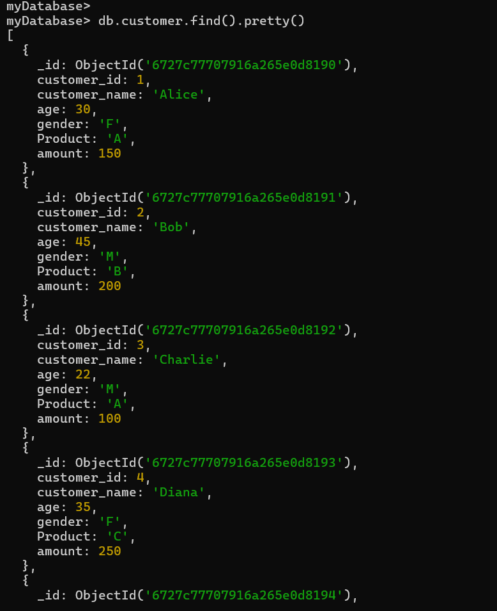
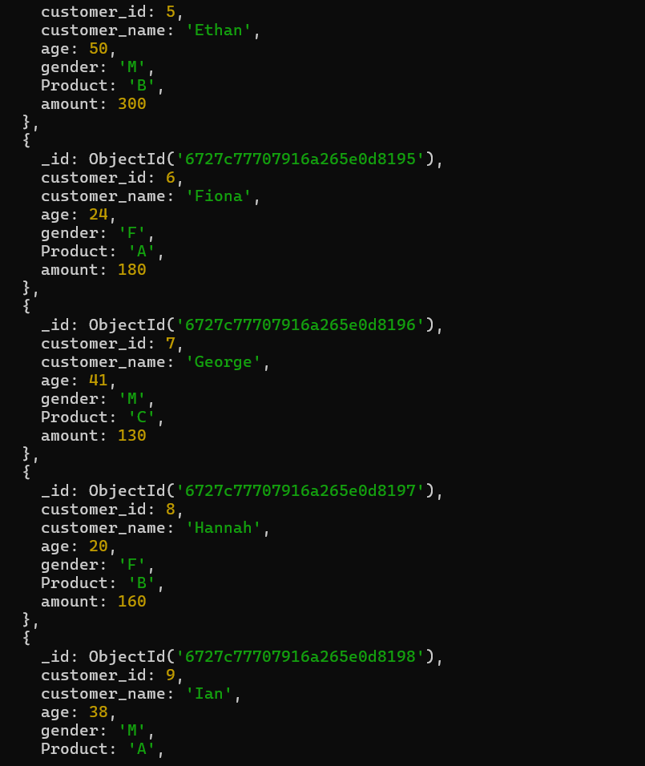
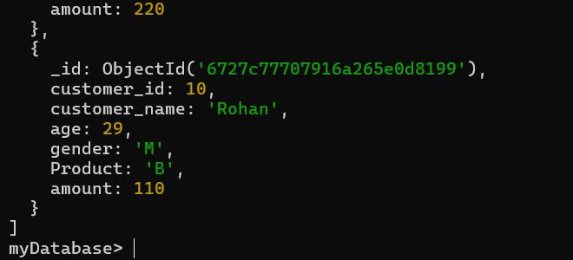

3) Retrieve documents that belong to customers older than 40.
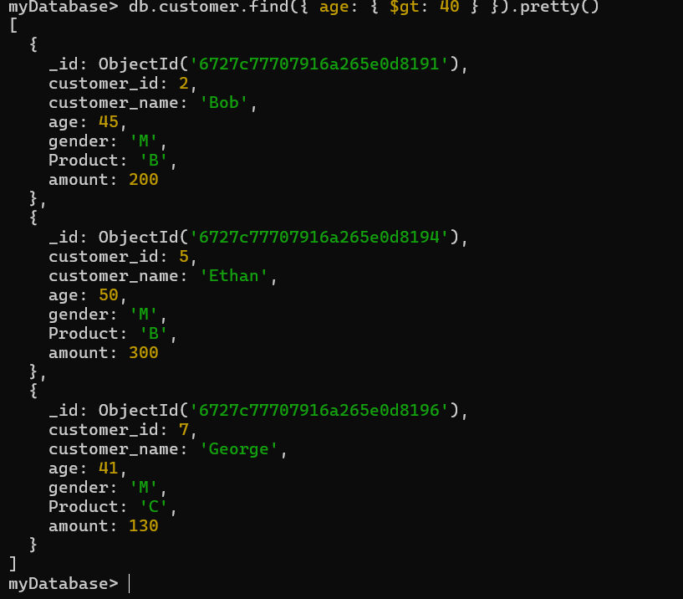
4) Retrieve documents that belong to female customers who are younger than 25.
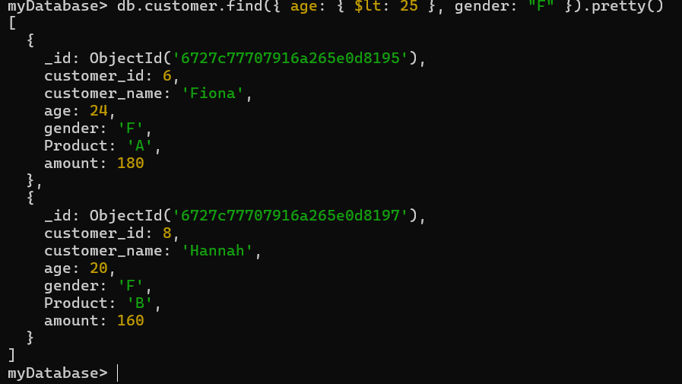
5) Update the documents of each customer who purchased product “B”, by adding a
newfield quantity:[&quot;10&quot;,”11”].
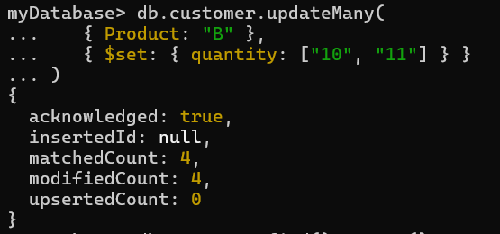

6) Update customer name :”Rohan” as “Ronald”
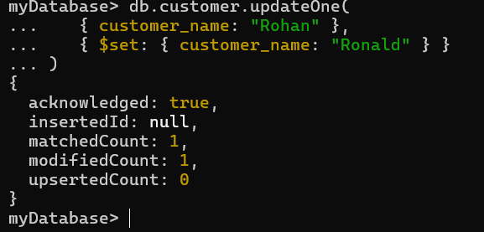
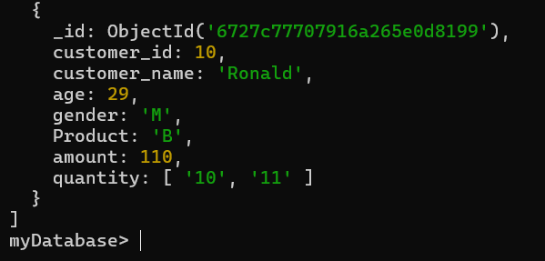
7) Delete the documents all customers whose gender is “F” and purchased the product “
A”.
8) Remove all documents.
